# **Background on Data Entry**

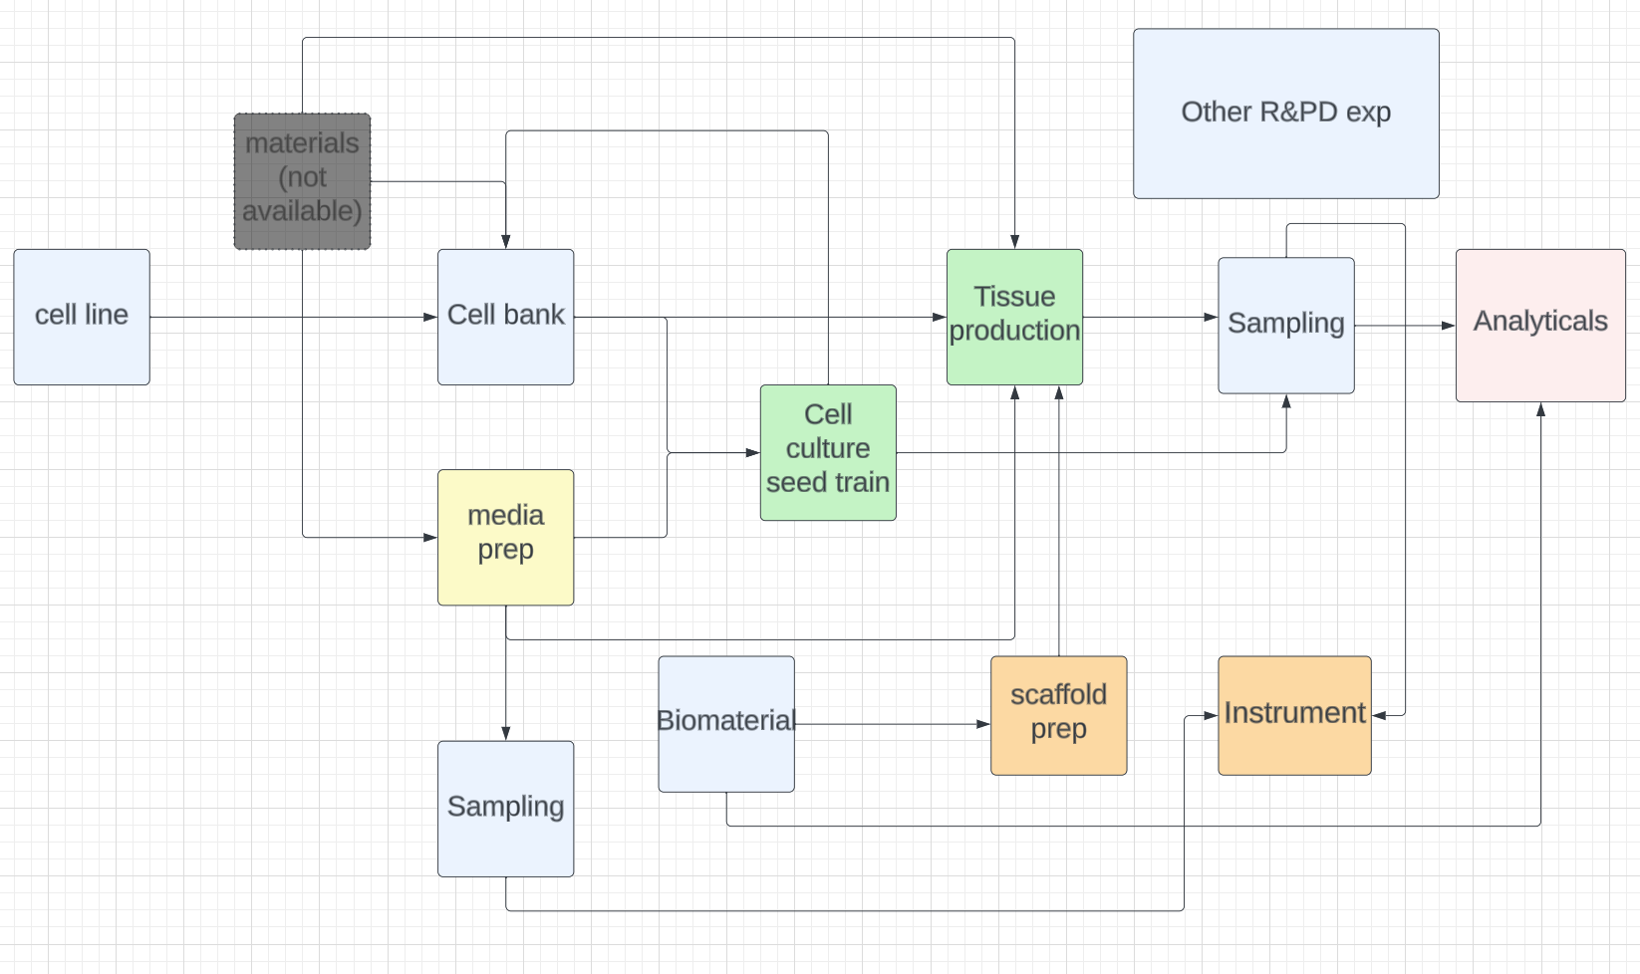

The Vitrolab database is designed according to the map above. Each block has 1 or more relationships with another block. Each block has its own template. So when there is data in these blocks, most of the information can be linked based on their relationship to other blocks, which provides data traceability.

It is imperative to ensure that data entry rules are followed, and information entered is accurate.

# **Useful shortcuts in googlesheets**

# 

# **Cell Inventory**

1. Instruction is written in notion: [cell cryo inventory](https://www.notion.so/vitrolabs/Automated-Cell-Cryo-Inventory-0d752069e8054ce49b292fbbf332375e?pvs=4)

# **Cell Line**

1. Go to [cell_line_development_tracker](https://docs.google.com/spreadsheets/d/1c4uoqqTQxDtNRtQrczaJQ5rTJ1PygK61jEwlfYRds8M/edit#gid=0)
2. Manually fill in column A through F (see reference for column name definitions)
3. From the options at the top Click on “Script”, and click on “Create experiment”

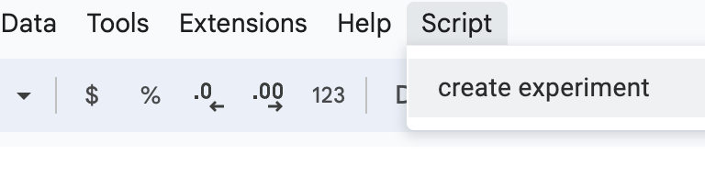

1. Google permission might show up, if it does, accept the permission and click on “Create experiment” again
2. A link should appear on column G. that is the link to your experiment

# **Media Prep**

# **Biomaterial & Scaffold Prep**

## Adding biomaterials

1. Go to [biomaterial_and_scaffold_prep](https://docs.google.com/spreadsheets/d/1-n2zwPWklDmYvsyYcuaSqdirkg1vnwAaMFXQvvDCyLc/edit#gid=0), sheet name “biomaterial”
2. Fill in column B through L (see reference for column name definitions)
   1. The sheet will reject certain entries if the format is not correct

## Prepping Scaffold

1. Go to [biomaterial_and_scaffold_prep](https://docs.google.com/spreadsheets/d/1-n2zwPWklDmYvsyYcuaSqdirkg1vnwAaMFXQvvDCyLc/edit#gid=0), sheet name “scaffold”
2. Fill in column C through M (see reference for column name definitions)
   1. The sheet will reject certain entries if the format is not correct
   2. Column C - D are dropdown columns. Go to step 3 - 6 for additional instructions on the dropdown columns
3. If a specific biomaterial_id does not appear in the dropdown, double check the material you are looking for. Once confirmed that it doesn't exist, go to “biomaterial” sheet and add in the new biomaterial.
4. If a specific form_factor_id does not appear in the dropdown, double check the material you are looking for. Once confirmed that it doesn't exist, go to “form factor” sheet and add in the new form factor
5. If a specific press_id does not appear in the dropdown, double check the press parameter in “press parameter” sheet . Once confirmed that it doesn't exist, add new entry in “press parameter” sheet
6. If you are not familiar with the autoclave_id, go to “autoclave specification” sheet for more information on the autoclave parameters. If the autoclave_ids does not meet your need, add new entry in “autoclave specification” sheet

# Seed train

# Tissue production

# Analytical

# Equipment

# Column Name Reference

## Cell Inventory

1. <https://www.notion.so/vitrolabs/Automated-Cell-Cryo-Inventory-0d752069e8054ce49b292fbbf332375e?pvs=4>

## Cell Line

| Column Names | Description |
| --- | --- |
| cell_line_id | manual entry of an unique id name of your choice. It will reject input if name already exist |
| cell_line_type | select from dropdown |
| released_for_cell_bank_and_seed_train | text column, type yes or no |
| characterization | select from dropdown |
| culture condition | text column, summarize culture condition |
| media condition | text column, summarize what type of media used |
| experiment_link | generated by script |

## Media Prep

## Biomaterial & Scaffold Prep

| **"Biomaterial" Column Names** | **Description** |
| --- | --- |
| biomaterial_id | unique id autogenerated |
| material_type | type of biomaterial (i.e PET) |
| description | describe the biomaterial |
| vendor | vendor name |
| received_date | received date (format = mmyy) |
| needle_punch | numeric value |
| manufacture_gsm | numeric value (gsm = grams/m2) |
| manufacture_thickness_mm | numeric value |
| areal_density_mg_per_cm2 | numeric value |
| total_cost | numeric value |
| total_length_m | numeric value, total length (m) of the biomaterial |
| used_m | numeric value, total length (m) of the biomaterial used |
| remaining_m | autocalculated, length (m) of biomaterial remaining |

## 

| **"scaffold" Column Names** | **Description** |
| --- | --- |
| id | index, automatically generated |
| scaffold_id | unique scaffold_id, generated automatically |
| biomaterial_id | dropdown, the id is linked to the biomaterial sheet |
| form_factor_id | dropdown, the id is linked to the form factor sheet |
| press_id | dropdown, the id is linked to the press parameter sheet |
| autoclave_id | dropdown, the id is linked to the autoclave specification sheet |
| post_press_weight_g | numeric value, weight of scaffold after pressing |
| thickness_mm | numeric value |
| weight_with_frame | numeric value, weight of scaffold with frame |
| coating_type | type of coating used (i.e PLL) |
| coating_volume_ml | numeric value, volume used to coat scaffold |
| date_prepped | completion date of scaffold prep (mmddyyyy) |

## 

| **"form factor" Column Names** | **Description** |
| --- | --- |
| form_factor_id | manual entry of bioreactor name |
| form_type | function of the form factor (i.e. Rocking, Perfusion) |
| tissue_geometry | shape of the tissue (i.e. rectangular) |
| tissue_culture_length_in | length of issue |
| tissue_culture_width_in | width of issue |
| tissue_culture_area_in2 | tissue area |
| internal_volume_ml | media volume of the chamber |
| internal_chamber_height_in | height inside the chamber |
| chamber_outer_length_in | external length of the chamber |
| chamber_outer_width_in | external width of the chamber |

## 

| **"press parameter" Column Names** | **Description** |
| --- | --- |
| press_id | unique id autogenerated |
| press_instrument | press instrument type |
| target_thickness_mm | target thickness of the scaffold |
| press_duration_s | how long to press for |
| offset_height_mm | additional height during pressing, usually a washer or slide is utilized for this offset |
| temperature_C | press temperature |
| pressure_psi | press pressure |

## 

| **"autoclave specification" Column Names** | **Description** |
| --- | --- |
| autoclave_id | unique id autogenerated |
| system | name of the autoclve system |
| cycle | cycle type (i.e. dry, wet) |
| cycle_name | cycle setting (i.e. sterilize, dry, gravity, etc) |
| sterilization_temp_C | sterilization temperature in C |
| dry_temp_C | drying temperature in C |
| exhaust_speed | speed of the exhaust |
| sterilization_time_min | sterilizlation time in minutes |
| dry_time_min | drying time in minutes |
| total_time_min | sterilization time + drying time |

**(note: autoclave parameters are taken from autoclave system settings)**

## 

## 

## Seed train

## Tissue production

## Analytical

## Equipment